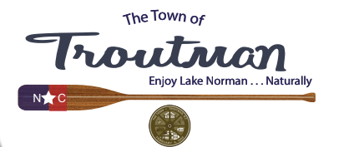

**Public Notice**

**DATE: April 04, 2022**

**The regular scheduled Town of Troutman Design Review Board Meeting of**

**April 7th, 2022 is cancelled due the lack of agenda items.**

**The next regularly scheduled Design Review Board Meeting will be held**

**May 5th, 2022 at the Troutman Town Hall, 400 North Eastway Drive,**

**Troutman, N.C.**

**Town Clerk**

**Kimberly H. Davis**