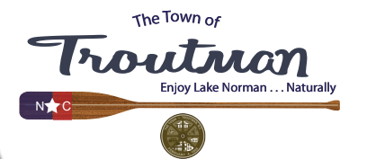

**Zoning Board of Adjustment Meeting**

**Thursday, May 16, 2024**

**3:00 PM**

**AGENDA**

1. **Call to Order**
2. **Moment of Silence and Pledge of Allegiance**
3. **Notice of a Quorum and Conflict of Interest Statement**
4. **Approve Meeting Minutes of April 18, 2024**
5. **SUP-24-01 Piedmont Landco, LLC:** 1132 Charlotte Highway (PIN 4750-02-0016) Request for a Special Use Permit to allow for Drive-Thru Use as required by CZ-HB-20-01).
   * Swear in Speakers
   * Hold Public Hearing
   * Consider Approval (with or without conditions) or Denial
6. **Adjourn**