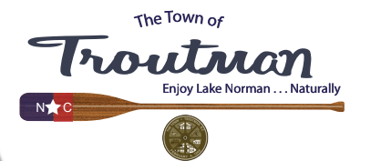 | Date: Monday, October 09, 2023  Time: 4:00 P.M. Council Meeting  Location: Troutman Town Hall  400 N. Eastway Drive, Troutman, NC
Agenda Briefing  {Note: This meeting is live video streamed. Board action may be taken on agenda items and other items of discussion} |  | Participants
I. Call To Order:  - Adjustments to Agenda Briefing Items  **Consider Approval of Resolution 34-23 Titled: “Resolution Authorizing the Town Manager To Execute A Real Estate Sale For Property Owned By The Town Of Troutman” as Item II. B. 2  **Addition of a Closed Session Pursuant to G.S. 143-318.11(a)(3) to Consult with Attorney as Item IV  - Agenda Adoption |  | Mayor Teross W. Young, Jr.  Mayor Young/Council
II. General Business:
- Mayor and Council Items: At this time Mayor Teross Young provides an opportunity for elected officials to make reports, comments, and/or ask questions.
  - Mayor and Council Comments
- Staff Items: At this time Mayor Teross Young provides an opportunity for staff to make reports, comments, and/or ask questions.
  - Town Manager/Staff Comments
  - **Consider Approval of Resolution 34-23 Titled: “Resolution Authorizing the Town Manager To Execute A Real Estate Sale For Property Owned By The Town Of Troutman”
III. Overview of Town Council’s Upcoming Regular October 12, 2023 Meeting Agenda Items Scheduled to be Presented  (Reference Draft Agenda Provided/Attached) |  | Ron Wyatt, Town Manager
IV. **Closed Session
- G.S. 143-318.11(A)(3) To Consult With Attorney
V. IV. Adjournment…Mayor seeks a motion and a second from Council.

- In accordance with the Americans with Disabilities Act, persons who need accommodations to attend or participate in this meeting should contact Town Hall at 704-528-7600 within 48 hours prior to the meeting to request such assistance.

